2. Patterns in Stereovision ( 4 pages)

In the remaining sections of the repot, the Fourier transform method used in the 2D spectral image matching, and associated padding functions, is implemented in place of library correlation functions because of its greater efficiency.

1. Calibration

This experiment considers the problem of mapping pixel space coordinates to real world coordinates to reproduce a depth assessment from stereo images. Parallax because of the position of eyes, or cameras, causes the position of an object to appear differently when viewed from different vantages. The effect appears more prominently when the object is closer, and less when it is more distant.

The calibration mapping is determined by an curve fitted to the location of calibration points of real world images, located at (x,y) with a corresponding calibration distance z. The coordinates formed the input data for which a regression was performed to relate pixel space locations to real world coordinates.

System of equations which mapped the pixel space values of Z and Y given the left and right camera images. Use a fitting tool to create a 4D surface fit which connects all pixel space to real space within your calibrated zone.

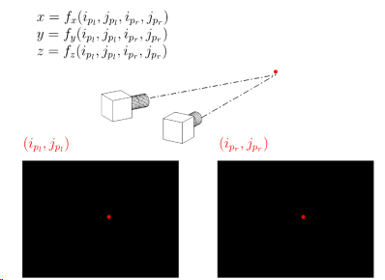

Data

 

These images are from a left and right camera, viewing the same calibration target at a stereo angle of approximately ±9◦. The calibration target has white dots spaced by 50 mm in the x (horizontal) and y (vertical) directions. The calibration target is shifted to various z locations, starting at a distance of 2000 mm from the camera, and shifted in 20 mm increments towards the camera (in the negative z direction). The calibration file names contain the name of the stereo camera (i.e left or right) and the z location of the calibration target (i.e 2000).

Each of the identified dots has a known (x, y, z) in real space (in mm). The datum is as shown in Figure 3, with x=0mm , y=0mm located at the 11th dot from the left, in the lowest row of dots. The coordinates of each common dot from the left image (il,jl) and the right image (ir,jr) are uniquely associated with a given (x,y,z) in real space. For example the coordinates of the lowest left-hand dot in the left and right images shown in Figure 3 correspond to the real space coordinates (-500, 0, 2000).

Model results

This method resulted in very accurate pixel-to-real-space mapping, with a very small margin of error within the now-calibrated area. To test, depth maps were generated for 3 image pairs which were valid for the calibration area, then these were converted to real space coordinates using the derived formula and can be seen in figure xx A clear 'bend' can be seen for each real space depth map, and some fraying is present at the top and bottom of test image pairs 2 and 3 . The bend is due to calibration error, while the fraying is due to the edges of the depth map having high values. This fraying can be easily removed by trimming the edges of the image.

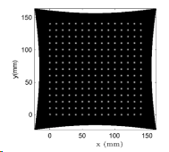

1. Creating depth maps

Depth mapping requires the correspondence between two stereo images, (figure x), to be determined. A more efficient image matching algorithm is implemented to find the cross correlation accurately between related pixels of the left and right images.

A search method using an enlarged window, xxx times greater than the passed pattern, is used as a search area. (figure) Similar to the 2D spatial correlation the search window is

The centre of the search area was deduced from the alignments to produce a spx dpy value which give the pixel space difference of the matched location in the template image (left), to search image (right). Stored in a bi-dimensional array, the offset values correspond the to the input values of a Euclidean distance calculation that returns the depth, z, as the distance from the camera. The greater the value of dpx, dpy, the closer to the camera the given point is, and correspondingly the opposite applies.

The algorithm is tested on a set of image pairs below: